Lesson 1 Glaciers Changing the Earth’s Surface
Sub-Driving Question: What type of landforms can glaciers create?
Objective(s): LWBAT demonstrate how glaciers can transform landscapes (Mastery).
LWBAT label glacial deposits and landforms (Mastery).

Grade(s): 3
Standards from the Michigan Department of Education:
E.SE.E.2 Surface Changes- The surface of Earth changes. Some changes are due to slow processes, such as erosion and weathering, and some changes are due to rapid processes, such as landslides, volcanic eruptions and earthquakes.
E.SE.03.22 Identify and describe natural causes of change in the Earth’s surface (erosion, glaciers, volcanoes, landslides, and earthquakes.
Materials: *note; needs to be prepared before class
labeled pictures in the “lesson plan for glacial landforms – pictures”
handout at the end of this lesson
------Activity 1----------------------------------------------------
10 plastic cups
1 jug of water
------Activity 2-----------------------------------------------------
Timer
Modeling Clay
*Ice Cubes (plan 2 ice cubes per student)
Sand Sediment
Paper towel, towels – for cleaning up

3-3:10 | Introduce topic to the students by asking these questions to get them to investigate their background knowledge. Using these leading questions will help you determine what the students already know about how landforms are shaped as well as to the Question of  What are landscapes?  -some might mention paintings; remind students that these paintings are showing the reality of how the Earth looks.  Show these bottom two pictures and ask what shapes the landscapes…  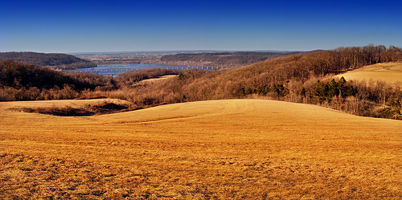  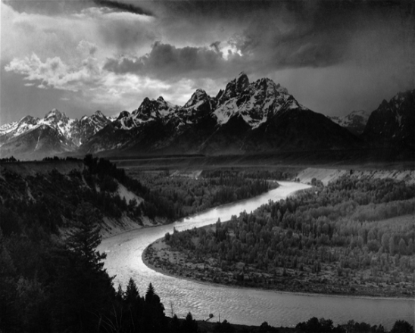  Source for both pictures: http://www.ratemyscreensaver.com/wp-content/uploads/2007/05/windowslivewriterlusciouslandscapes  What events shape our Landscapes?  -volcanoes, earthquakes, landslides, rivers might be the popular few.  What factors shape our landscapes? Does Water have an effect on landscapes? How?  -Yes  -rivers erode areas were sediment once laid and then transports the sediment to a new area.  Do you know any examples of how Ice and/or Snow has shaped landscapes?  -Have any of you ever seen pot holes on roads? These are places where water has gotten into cracks in the road and then when the ice froze it has expanded to push the cracked pavement away from itself. Once the ice melts in warmer temperatures the more widely cracked pavement is exposed to cars going over it and breaking large holes in the road.  Ice and snow are most effective on landscapes when they accumulate. Do you know what accumulation means?  -the gathering of lots of one or more things… ice is most effective like this  Have you ever seen a pine tree that gathered a lot snow on its branches? And once it gathered too much snow and ice it began to bend under the weight? Demonstrate for me what a tree would look like if their branches became very heavy with the weight of the snow  -spread your arms out and slowly lower them because you can no longer support the weight of the snow and ice.
Today we are going to be learning about how glaciers affect the landscapes around us and then tomorrow we will talk about how important they are to us here in Michigan.

Since glaciers hold the almost 70% of Earth’s freshwater, a demonstration of this diagram given by the USGS can be shown.
- Start with a 10 clear cups and a large jug of water
- Ask students of the 10 cups how many should you fill to represent the amount of freshwater that is held in glaciers?
- Gather a sampling of suggestions
- Once finished gathering samplings fill 7 of the 10 cups to represent the glaciers holding that much freshwater
- Fill 3 cups for groundwater as one of those cups represents the amount of water within rivers, lakes and surface water.

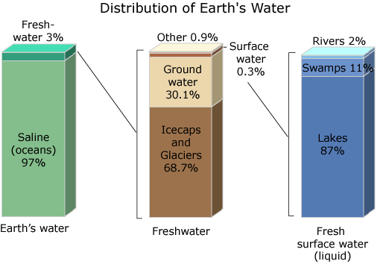http://ga.water.usgs.gov/edu/watercyclesummary.html

3:15-3:35 | Show picture below to show scale of how big a glacier actually is. You do not have to say this, but the glacier in this picture is over 50 km long. To a turn and talk partner ask them what they think the black parts of the glacier are. They are labeled moraines, but what does that mean? If snow and Ice is normally white what could be the “dirty” color on the glacier?  - the hint will hopefully get them to dirt of sediment  Answers will vary but just write them on the board and then go back to picture at the end of the clay, ice and sand erosion exercise.  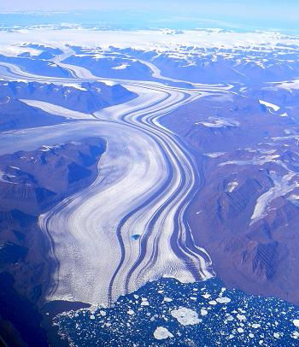  Source: http://www.beloblog.com/KGW_Blogs/weather/archives/2007/09/the_melting_con.html  A recent photo of Greenland's shrinking glaciers, courtesy of Creative Commons  **Pass out the pictures of the glacier named with its moraines- these are just areas were a lot of sediment or dirt has accumulated on the glaciers  Glaciers are often called dirt movers or dirty glaciers, because they often look like large mounds of dirt with little ice actually visible.  Erosion is a very large part of how glaciers change landscapes compared to that of the “instant sediments” made by volcanoes or the large splits in the Earth’s surface made from earthquakes.  Who knows what erosion means? (Questions)  -let students take some guesses by writing the main words up on the board  *wind *smoothing  *ice *breaking off  *grinding *changing  - Definition is the process by which a surface of the Earth is worn away by the actions of water, glaciers, wind, waves, etc.  Students Begin Experiment: Pass out a small amount of clay just slightly smaller than the size of a ping-pong ball.  Before we pass out ice cubes, tell students that they are going to melt in our hands and that’s ok—but these ice cubes should not go in anyone’s mouth. They are for the experiment we are about to run and if anyone tries melting their ice cube faster than normal they cannot continue with the experiment. Also when your fingers become too cold to do this, you may pause and continue once your fingers are warm again. (Safety)  Instructions:  - Press your ice cube onto the clay and rub it back and forth several times. (Use this time for the students to get in their 3 minutes of getting to know the material before working with it.) Once they are done rubbing (not pushing down) on the ice cube across the clay ask students to tell what they observed. Put all suggestions up on the board that would apply to what the clay looks like afterwards as well as the ice cube. There is most likely quite a bit of melting that occurred in which should be noted.  - Then place a small amount of sand (about a tablespoon worth) on each of the students’ clay and ask students to JUST let the ice cube sit on the sand and clay for 1 minute. Using a timer to keep track of the 60 seconds. Once the time is up have students pick up the ice cube and record their observations of the bottom of the ice cube.  - This time place put the same side of the ice cube down on the sand, but this time pushed back and forth along the clay surface several times (no specific time limit, just until there is some sediment stuck to the bottom of the ice cube and striations have formed in the clay). Afterwards, take the cube away and look at the base of the ice cube as well as brush away the excess sediment from the clay and observe the structures on the clay surface.  (Activity taken from the Fruit Belt Soil website from the Erosion Lesson plan for elementary. http:// www.michiganfruitbelt.org/soil)  Questions during or after the activity:  What did the surface of the clay look like after rubbing the ice against it verses rubbing the sediment and ice against it? (priority to evidence)  -the clay was smoothed and wet from the first trial while the sediment left striations in the clay in the second trial.  **Show picture of striations in a rock from the pictures document. The picture shows the striations going from the bottom to top of the page while the layers going right to left are not striations. These are layers of bedding- the way sediment had been laid down and compressed to form the rock first. If you live in Michigan or the surrounding areas where outwash is common for your area you might be able to find some striated rocks out in the playground or in your backyard. An alternative activity could be going hunting for striated rocks as a class.  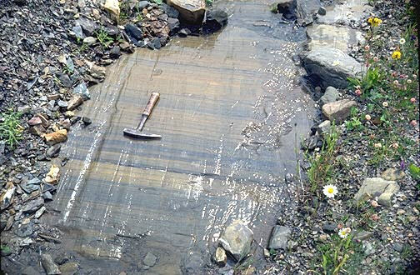What happened to some of the sediment on the bottom of the ice cube?  -some of the sediment was picked up by the glacier  What do you think the ice cube represents? What do you think the Clay represents? What does the Sand represent? (formulate explanations)  -the glacier, earth’s surface and boulders as well as other sediment pieces that are picked up in the glacier.  What do you think happens to the water after a glacier starts melting?  -forms rivers and lakes just as it formed puddles on our desks.  Where would the sediment go when the glacier is melting? (evaluate their explanations)  Remember a glacier picks up and smoothes the Earth’s surface, but once there is no longer any ice it will drop the sediment wherever it was left to sit.  ----this can be demonstrated again with the ice cube if you just leave something on the table.  **Refer back to the picture at the top of this cell and ask the students again what the picture is showing with the dark lines of sediment and the melt water at the mouth of the glacier.  ***As an extension, have your class can go on a rock hunt to find a rock with these striations. You can probably find one in the playground as well as at home. Make sure the rock is as big as the palm of your hand in order to see the striations. Putting some water over it will usually help in seeing the carved lines.
3:35- 3:50 | Show the pictures of some landforms formed by glaciers.  - Picture of the Outwash and Glacier: Show how the glacier melts and the water creates these streams in the front of the glacier. The outwash is sand and dirt that are being “washed out” of the glacier; the stream water carries them away from the glacier. Note that most glaciers are called dirty glaciers because of the amount of sediment they contain.  - Picture of Moraine Types: Granted there are more pictures on the image than needed, yet all we need to know are the terminal otherwise known as end moraines and the medial moraines. Ask students what words they can use to describe each of these moraines.  -medial- middle of glacier  - terminal – end of the moraines  -end – cap of the end of the glacier  - Picture of the U-shaped Valley: This valley is created as the glacier flows through a valley that was a V-shape to carve out the shape of the glacier itself. The U-shape Valley is a good visual for what happened when the land on both side of the glacier are higher than the middle (where the glacier flows down). However, this is not what formed the Great Lakes, that was by the process of erosion -strictly, but maybe you can used this to talk to your students about during the next lesson.  - Picture of the Kettle Lakes- Large chunks of ice that fall off from the front of the glacier and melts in to an inland lake. The reason why they are called inland lakes is because they are not attached to any river systems but instead the water is renewed by the groundwater that flows around and through the lake. There are many of these lakes in Michigan because we had so much glacial activity.
3:35-3:45 | Show pictures of 3 different landscapes and ask students some ways they think that glaciers could have shaped the landscapes. Hand out a picture of the landscape attached and ask students to circle at least 3 landforms that you think have been affected by glaciers. Label the landforms A, B, and C and write 2 sentences on why you think they are glacial landforms below. (communicate and justify)
Evaluations:
I will know that the LWBAT demonstrate how glaciers can transform landscapes when they give priority to evidence in the answering section after the second activity.
I will know that the LWBAT label glacial deposits and landforms when they communicate and justify what landforms can be seen in the last handout.

Name________KEY__________

http://landscapemodelling.net/jpg/upsala-glacier-in-patagonia-1.jpg

In this picture circle at least 3 landforms that you think have been affected by glaciers.
Label the landforms A, B, and C and write 2 sentences on why you think they are glacial landforms below.

A Outwash – The water is melting from the front of the glacier and caring some sediment but mostly water. Kettle Lake- The glacier must have broken off a chunk of ice to melt in form a large lake like this one.

B Moraines-Located on the sides of the glacier. This one could be a medial moraine since it is not at the end of the glacier “capping” the glacier off.

C Outwash- The sediment makes me think that this is part of the outwash. The outwash needs to have water and sediment which water is placed all around the sediment. End Moraine- Looks like an End Moraine to me since it is at the front of the glacier making it look capped off.

Remember: there can be several answers, this activity is to see what they understand about each of the glacial features.

Name______________________________

http://landscapemodelling.net/jpg/upsala-glacier-in-patagonia-1.jpg

In this picture circle at least 3 landforms that you think have been affected by glaciers.
Label the landforms A, B, and C and write 2 sentences on why you think they are glacial landforms below.

A

B

C

