Education 254 Fall

Date: Oct. 23-2008

Lesson 1 Plants Need Air to Survive

Sub-Driving Question: What does air have to offer plants?

Objective(s): LWBAT describe resources for plant growth.

LWBBAT explain their observations using background knowledge.

Grade(s): 4

Standards:

L.OL.E.1 Life Requirements- Organisms have basic needs, Animals and plants need air, water, and food. Plants also require light. Plants and animals use food as a source of energy and as a source of building material for growth and repair.

L.OL.04.15 Determine that plants required air, water, light and a source of energy and building material for growth and repair.

Background Knowledge:

Just like humans, plants need food too. Yet, they make their food through a process called photosynthesis. Photosynthesis is when plants are able to convert energy from sunlight into a simple sugar, glucose. This occurs as carbon dioxide and water are taken in, glucose is produced, and oxygen and water are given off. The chloroplasts, small green-pigmented units within a cell containing chlorophyll, are responsible for the absorption of light that drives photosynthesis in plants. Glucose is used to produce other sugars and starch that in turn, through cellular aerobic respiration, may use some of the oxygen produced to form CO2, water, and energy.

Materials: *note some need to be prepared before class  
Spinach leaves (1 leaf per student)  
Sodium bicarbonate (Baking soda)- 1/8 of a teaspoon of baking soda in 300 ml of water  
Liquid Soap – 1 to two drops in the 300 ml  
Plastic syringe (10 cc or larger)—remove any needle!   
Hole punch   
Clear Plastic cups   
Timer   
Light source: Heat lamp * Make sure students are carful around the heat lights as they are very, very hot!!  
Green Light Source: green pop bottles, clear bottles with green food coloring, green colored glass wine bottles, green party light (buy them at the grocery store)

|  |  |
| --- | --- |
| 3-3:05 | Background  Sample students’ knowledge of why people need plants (include for oxygen if not up on the board), and why people are important for plants (include for carbon dioxide on the board). Include the above explanation of photosynthesis, except use sugars or starch instead of glucose. (questioning) |
| 3:05-3:06 | We are going to look at one illustration in how plants use carbon dioxide and produce oxygen  We are going to use Spinach leaves to observe photosynthesis in action by measuring oxygen produced. |
| 3:06-3:15 | Inquiry and Questioning:  *Hold demonstration of taking a leaf and punching holes out using the hole punch and filling my cup half full of water. (questioning)  -What do you think will happen when I put my leaves in the water?  -What happens when you go into a big body of water like a pool or a lake?  (use guided questions to get to the point that we float)  -Why do we float?  (because we have air, including oxygen and carbon dioxide in us that help keep us afloat just like the plants) |
| 3:15-3:20 | Students Begin Experiment:  *Pass out the Cups, paper hole punches, and leaves  (1 per student or group of 2)  *Students are to punch 10 holes out of each of their leaves and leave them on the table (TRY to AVOID the veins of the leaf)  *Show students how the baking soda is acting as the carbon dioxide (or us breathing). Place a sign on the Baking powder that says Carbon Dioxide so that the students can see it in the far back of the classroom.  *Each of the students is to write Carbon Dioxide on their cups with their names. ( ONLY write on one side of the cup so not to block light or watching the disks in the solution) |
| 3:20-3:35 | Leaf Disk Procedure  Explain to students “I am going to be giving a lot of directions, and If you don’t hear me, your experiment might not work. This is not a time to stop paying attention, since I will be questioning what you think will be going on after our procedure is finished.”  I will vacuum each of your samples myself:  (Remove the piston or plunger and place the leaf disks into the syringe barrel. Replace the plunger being careful not to crush the leaf disks. Push on the plunger until only a small volume of air and leaf disk remain in the barrel (< 10%). )  Explain the following I model it for the students.  1.Pull a small volume of sodium bicarbonate solution into the syringe.  Tap the syringe to suspend the leaf disks in the solution.  2.Holding a finger over the syringe-opening, draw back on the plunger to create a vacuum.  Hold this vacuum for about 10 seconds.  While holding the vacuum, swirl the leaf disks to suspend them in the solution.  3. Let off the vacuum.  The bicarbonate solution will infiltrate the air spaces in the leaf causing the disks to sink.  You will probably have to repeat this procedure 2-3 times in order to get the disks to sink. **If you have difficulty getting your disks to sink after about 3 evacuations, it is usually because there is not enough soap in the solution.  Add a few more drops** **of soap**. **If bubbles are present with the leaf disks, then there is too much soap.**  4. Pour the disks and solution into a clear plastic cup.  Add bicarbonate solution to a depth of about 3 centimeters.  Use the same depth for each trial.  Shallower depths work just as well.  (Williamson, B., 2008) |
| 3:35-3:45 | * *As a Control I (the Teacher) should have leaf disks that have been vacuumed exactly the same, but set them under room light and see if any of them rise to the top. The cup should be labeled “Room light.” and started under the same conditions listed below. * Place under the light source and start the timer. At the end of each minute, record the number of floating disks. Then swirl the disks to dislodge any that are stuck against the sides of the cups. Continue until all of the disks are floating. |
| 3:45-3:55 | Stop and Ask Some Questions: Students need to Return to seats  *Hand out Worksheet Asking: -Tell me what you observed (priority to evidence) -Explain to me why you think this happened (explanations) -What important resource did we observe today? Why it important to plant life?  -Are there any other important resources needed for plant life?  -Does it make sense that air is included in that group of resources? Why? (evaluate explanations) |
| 3:55-4 | Discuss as a group why we think the oxygen and carbon dioxide is important to plants as well as people. (communicate and justify) |
| Sources:  American Forest Foundation, 2007. Project Learning Tree Pre K-8 Environmental Education Activity Guide. Washington , D.C.<www.plt.org>  Williamson, B., 2008. The Floating Leaf Disk Assay for Investigating Photosynthesis. <http://www.elbiology.com/labtools/Leafdisk.html> | |

**Name_______________________**

**White Light _________ Light**

|  |  |  |  |
| --- | --- | --- | --- |
| **Number of Minutes** | **Number of Leaf Disks Risen** | **Number of Minutes** | **Number of Leaf Disks Risen** |
| **1** |  | **1** |  |
| **2** |  | **2** |  |
| **3** |  | **3** |  |
| **4** |  | **4** |  |
| **5** |  | **5** |  |
| **6** |  | **6** |  |
| **7** |  | **7** |  |
| **8** |  | **8** |  |
| **9** |  | **9** |  |
| **10** |  | **10** |  |
| **11** |  | **11** |  |
| **12** |  | **12** |  |
| **13** |  | **13** |  |
| **14** |  | **14** |  |
| **15** |  | **15** |  |
| **16** |  | **16** |  |
| **17** |  | **17** |  |
| **18** |  | **18** |  |
| **19** |  | **19** |  |

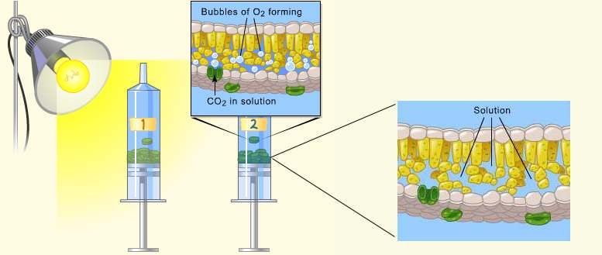

Name______________________



Date______________________

Observations On Plant Disks

List Your Observations during the Experiment:

1. Explain why you think this happened (give evidence).

2. What important resource did we observe today? Why it important to plant life?

3. Are there any other important resources needed for plant life?

4. Does it make sense that air is included in that group of resources? Why?



Water



**CO2**

**Carbon Dioxide**

